Slide 4,12 add latex color
Slide 8 add google scholar link?
Slide 12: text, color latex?: make it with color

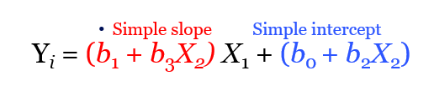
Slide14: picture to latex..

Exercises:keep them
Load.csv from canvas?
Some guessing, slide 20 no exercises…

